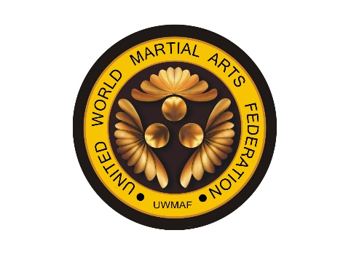

UNITED WORLD MARTIAL ARTS FEDERATION (UWMAF)

Osu,

Thank you for inquiring to apply for membership to the UWMAF.

- The United World Martial Arts Federation is fast becoming one of the world’s largest non-political Martial Arts Federation in the world.
- The UWMAF caters to all Traditional styles of martial arts.
- The UWMAF has two main Headquarters, one in Johannesburg, South Africa, and one in Tokyo Japan.

Our goal is to promote traditional martial arts to its fullest potential by supporting our members and uniting masters globally.

UWMAF believes that by offering world-class tournaments, Seminars, training Camps, ranking system and a method to recognize grades and underwrite them has created a platform in which Sensei’s, Shihans, Sifu’s and Kanchos can stand side by side and work together in promoting the way of Budo. More information can be found on the UWMAF website:

- MEMBERSHIP FEE
Membership to the UWMAF is USD 100.00 per individual instructor. For Membership, you will be issued the following.
1. UWMAF Martial Arts card.
2. Your UWMAF dan recognition Certificate underwriting your current grade
and style.
3. UWMAF Your Dojo Registration Certificate
4. UWMAF key ring
5. UWMAF arm patch
6. UWMAF calendar

- MEMBERSHIP PROCEDURE
1. Once you have forwarded all the documents required for joining as shown on the attached checklist, your membership application will be reviewed and if accepted you will receive a confirmation letter within 48 hrs. of the UWMAF receiving your application.

2. At this, you will deposit your membership fee into the UWMAF account which will be shown on your confirmation letter.

3. The UWMAF will issue your certificate within 30 days of receipt of your membership fee of USD 100
Required documents for UWMAF membership

Requirement | Yes | No
Certificate of Dan or Grade
Your history in Martial Arts
Photo in uniform (Dogi) in a kneeling position
UWMAF Application form completed

Please Scan and forward all of the above to:-uwkfhq@gmail.com to commence your application process.

Please note that once your Dan or grade is certified and underwritten by the UWMAF it will be recognized by all UWMAF members and associated Federations that are official members of the UWMAF (United World Martial Arts Federation)

Please visit the UWMAF official site www.uwmaf.net for any further information and tournament and event dates.
You can also follow UWMAF on Facebook. Please don’t hesitate to use UWMAF to promote your next event.

As an official member, you have the right to train with any of our International Instructors from the United World Martial Arts Federation Technical Committee or invite these instructors for your Dojo or Federation camps and seminars. We can even arrange world-ranked masters for different martial arts that are aligned with the UWMAF. You will also receive invites to all camps and seminars and have the right to use the UWMAF logo on all your advertising.

When traveling to another country, don’t hesitate to visit UWMAF members and dojos.

Thank you for your interest in UWMAF and your support and welcome to the United World Martial Arts Federation.

Regards

Kaicho Imtiaz Abdulla
United World Martial Arts Federation

WWW.uwmaf.net

